UCD School of Electrical, Electronic



& Communications Engineering

EEEN40010 Control Systems

Signed: _________________________________

Date: _________________________________

Minor Project 1 Control Systems Report

*Fergal Lonergan 13456938*

**Declaration: I declare that the work described in this report was done by the person named above, and that the description and comments in this report are my own work, except where otherwise acknowledged. I have read and understand the consequences of plagiarism as discussed in the EECE School Policy on Plagiarism, the UCD Plagiarism Policy and the UCD Briefing Document on Academic Integrity and Plagiarism. I also understand the definition of plagiarism.**

Minor Project 1 Control Systems Report

# Question 1

For question one we were tasked with measuring the effects of gains, poles and zeroes on a system. We were given the following zero pole controller with gain:

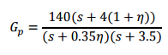

My eta value was 1.05.

To find my damping ratio $ξ I used the formula given in the notes:$



Then $ξ= \sqrt{\frac{{\ln\left(\frac{25}{100}\right)}^{2}}{{\ln\left(\frac{25}{100}\right)}^{2}+π^{2}} }=0.404$

I know also my dominant pole must lie to the left of $-\frac{4}{0.9}= -4.444$ to achieve the correct settling time.

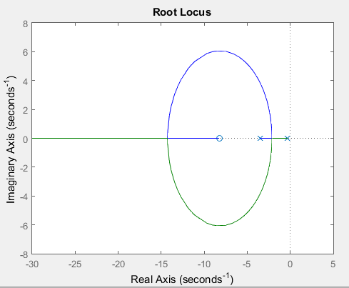

As we can see from the locus of our plant at the moment we cannot get a dominant pole close to the imaginary axis like we’d like to but still to the left of our -4.44 constraint for our pole. Therefore I propose to place a zero at -4 as this will open up any value from -4 onwards for a dominant pole to occur in our system. Then I will place pole at -8 as it is far to the left of -4.44 as we’d want it to be for our settling time yet not too far away as to be a ridiculous value.

For k, my gain, I calculate it as so:

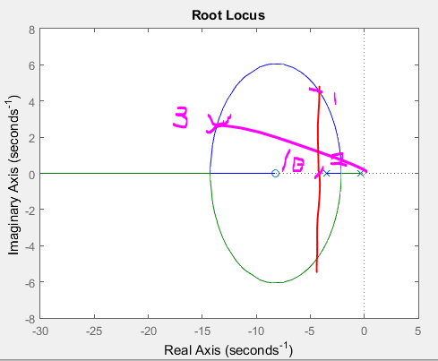

The following graph has 3 points marked 1,2 and 3. $θ$ is the angle related to my damping ratio by $θ=\tan^{-1}{ ξ}$ and the red line marks my -4.44 line. My gain k must be greater than the gain at points 1 and 3 and smaller than that at point 2. At the moment we cannot get a gain value for the point at 2 as it doesn’t lie on our locus so we just look at $k_{1}and k_{2}.$ We also say:

$$k≤\frac{140\left(4\left(1+η\right)\right)}{\left(0.35η\right)\left(3.5\right)}≈327$$

$$k_{1}=0.0355$$

$$k_{3}=0.163$$

So I chose a gain of 0.4.

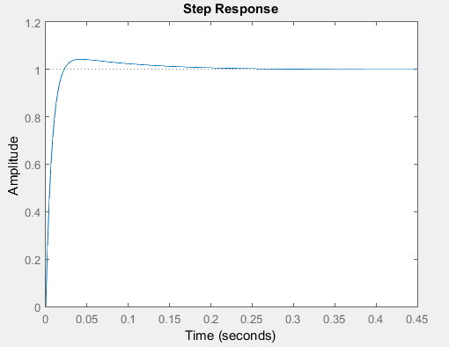

My percentage overshoot is 4.35% so it is within the tolerance, if a little fast. My settling time is 0.21 seconds, which is within our tolerance and an acceptable value. My rise time is quite fast at 0.02 seconds.   
My steady state is at 0.999 which is only a 0.1% error so I am very happy with this.

I then tested by poles in different locations and changing my gain. Changing my gain if felt didn’t really have a huge effect on my response, however it did have an effect in my on my system response times. Making them more negative made the response time of the system larger.

# Question 2

Linearized model at our Operating point

We were provided with the following operating point:

$$u_{0} ≠ 0,v_{0}= 0, { w}_{0}= 0$$

$$p_{0} = 0, q_{0} = 0, r_{0} = 0$$

$$X_{0} ≠ 0, Y_{0} = 0, Z_{0} ≠ 0$$

$$L_{0} = 0, M_{0} = 0, N_{0} = 0$$

$$ϕ_{0} = 0, θ_{0} = 0, ϕ_{0} = 0$$

The equation for the forces acting on an aircraft is described as follows (This includes the Coriolis Modification):

$\vec{F}= m\frac{d\vec{v}}{dt} + m\vec{ω} × \vec{v}$

We can also equate the sum of the thrust, force of gravity acting on the aircraft and the drag force components on the aircraft:

$$\left(2\right)\vec{F}= {\vec{F}}_{thrust} + {\vec{F}}_{gravity} + {\vec{F}}_{drag}$$

Firstly we’ll linearize (1) at the operating point with our offsets. The offsets are very small so their products are approximately 0 so all products of offsets are considered negligible:

$$m\frac{d\left(\vec{v}+ \tilde{\vec{v}}\right)}{dt} = m\frac{d}{dt}\left[ \begin{matrix}u_{0} + ũ \\ v_{0} + ṽ \\ w_{0} + \tilde{w}\end{matrix}\right]= m\frac{d}{dt}\left[ \begin{matrix}u_{0} + ũ \\ \tilde{v} \\ \tilde{w}\end{matrix}\right] = m\left[\begin{matrix}\frac{d\tilde{u}}{dt} \\ \frac{d\tilde{v}}{dt} \\ \frac{d\tilde{w}}{dt}\end{matrix}\right]= m\left[\begin{matrix}ũ̇ \\ ṽ̇ \\ w̃̇\end{matrix}\right]$$

$$m(\vec{ω} + \tilde{\vec{ω}} ̃) × (v⃗ + \tilde{\vec{v}}) = m \left[\begin{matrix}\hat{i} & \hat{j} & \hat{k} \\ \tilde{p} & \tilde{q} & \tilde{r} \\ u_{0} + \tilde{u} & \tilde{v} & \tilde{w}\end{matrix} \right] = m\left[\begin{matrix}0 \\ \tilde{r}u_{0} \\ -\tilde{q}u_{0}\end{matrix}\right]$$

If we combine the terms we find a linearized expression for the force:

$$F⃗ = m \left[\begin{matrix} \dot{\tilde{u}} \\ \dot{\tilde{v}}+\tilde{r}u_{0} \\ \dot{\tilde{w}}+-\tilde{q}u_{0}\end{matrix}\right]$$

If we look at expression (2) we note it can be linearized at the operating point too. The y component of the thrust is 0, the z component is a non-zero constant:

$$\vec{F} = \left[\begin{matrix}T_{x} \\ 0 \\ T_{z}\end{matrix}\right] + \left[ \begin{matrix}-mg sin θ \\ mg sin ϕ cos θ \\ mg cosϕ cos θ\end{matrix}\right] + \left[ \begin{matrix}X \\ Y \\ Z\end{matrix} \right]$$

Considering first the gravity term at the operating point:

$$\left[\begin{matrix}mg\sin\left(θ_{0} + \tilde{θ}\right) \\ mg\sin\left(ϕ_{0} + \tilde{ϕ}\right)-\cos\left(θ_{0} + \tilde{θ}\right) \\ mg\cos\left(ϕ_{0} + \tilde{ϕ}\right)\cos\left(θ_{0} + \tilde{θ}\right)\end{matrix} \right]= \left[\begin{matrix}-mg\sin\left(\tilde{θ}\right) \\ mg\sin\left(\tilde{ϕ}\right)\cos\left(\tilde{θ}\right) \\ mg\cos\left(\tilde{ϕ}\right)\cos\left(\tilde{θ}\right)\end{matrix}\right] ≈ \left[\begin{matrix}-mg\tilde{θ} \\ mg\tilde{ϕ} \\ mg\end{matrix}\right]$$

Small angle approximations were used for the trigonometric functions where for a small x sin 𝑥 ≈ 𝑥 and cos 𝑥 ≈ 1.

We now linearize the drag component using multivariable Taylor expansions.

𝑋 = 𝑋(𝑢, 𝛼, $δ_{e}$),

𝑌 = 𝑌(𝛽, 𝑝, 𝑟, $δ_{r}$),

𝑍 = 𝑍(𝑢, 𝛼, 𝛼̇ , 𝑞, $δ_{e}$)

Including offsets:

$$X_{0} + X̃ = X(u_{0}, α_{0}, δ_{e0}) + {\left(\frac{∂X}{∂u}\right)}_{OP} \tilde{u} + {\left(\frac{∂X}{∂α}\right)}_{OP} \tilde{α} + {\left(\frac{∂X}{∂δ_{e}} \right)}_{OP}{\tilde{δ}}_{e}$$

$$Y_{0} + \tilde{Y} = Y(β_{0}, p_{0}, r_{0}, δ_{r0}) + {\left(\frac{∂Y}{∂β}\right)}_{OP} β̃ + {\left(\frac{∂Y}{∂p}\right)}_{OP} \tilde{p} + {\left(\frac{∂Y}{∂r}\right)}_{OP} r̃+ {\left(\frac{∂Y}{∂δ_{r}}\right)}_{OP} {\tilde{δ}}_{r}$$

$$Z_{0}+\tilde{Z} = Z\left(u_{0}, α_{0}, {\dot{α}}_{0}, q_{0}, δ_{e} \right)+{\left(\frac{∂Z}{∂u}\right)}_{OP}\tilde{u}+{\left(\frac{∂Z}{∂α}\right)}_{OP}\tilde{α}+{\left(\frac{∂Z}{∂\dot{α}}\right)}_{OP}\tilde{\dot{α}}+{\left(\frac{∂Z}{∂q}\right)}_{OP} \tilde{q}+{\left(\frac{∂Z}{∂δ_{e}} \right)}_{OP}{\tilde{δ}}_{e}$$

At the operating point the above linearizations are re-written as follows:

$$X_{0} + \tilde{X} = X_{0} + {C_{X}}_{u } \tilde{u} + {C_{X}}_{α} \tilde{α} + {C_{X}}_{δe} {\tilde{δ}}_{e}$$

$$Ỹ = {C_{Y}}_{β} \tilde{β} + {C_{Y}}_{p} \tilde{p} + {C_{Y}}_{r} r̃+ {C_{Y}}_{δr} {\tilde{δ}}_{r}$$

$$Z_{0} + \tilde{Z} = Z_{0} + C_{Z_{u}} \tilde{u} + {C_{Z}}_{α} α̃ + C_{Z\dot{α }}\tilde{\dot{α}} + C_{Z_{q}} \tilde{q} + {C_{Z}}_{δe} {\tilde{δ}}_{e}$$

Therefore we can re-write our entire linearized force equations as:

$\vec{F}= \left[\begin{matrix}T_{x} – mg\tilde{θ} + X_{0} + {C_{X}}_{u} \tilde{u} + {C_{X}}_{α} \tilde{α} + {{C_{X}}_{δ}}_{e} {\tilde{δ}}_{e} \\ mg\tilde{ϕ} + {C_{Y}}_{β} \tilde{β} + {C_{Y}}_{p} \tilde{p}+ {C_{Y}}_{r} \tilde{r}+ {C_{Y}}_{δr} {\tilde{δ}}_{r} \\ T_{z} + mg + Z_{0} + C_{Z_{u}} \tilde{u} + C_{Z_{α}} \tilde{α} + C_{Z\dot{α}} \tilde{\dot{α}} +C_{Zq} \tilde{q}+C_{Z_{δe}} {\tilde{δ}}_{e} \end{matrix}\right]=m\left[\begin{matrix}\dot{\tilde{u}} \\ \dot{\tilde{v}}+\tilde{r}u_{0} \\ \dot{\tilde{w}}-\tilde{q}u_{0}\end{matrix}\right]$

Now that we have the linearised equations for the force acting on the aircraft we now consider the moment.

$$\vec{M} =\frac{d\vec{H}}{dt} + \vec{ω} × \vec{H} = \left[ \begin{matrix}L \\ M \\ N\end{matrix} \right]; \vec{ω} = \left[ \begin{matrix}p \\ q \\ r\end{matrix} \right]$$

Te angular momentum $\vec{H}$ = 𝐼 $\vec{ω}$, therefore we can consider the second term in the moment vector equation (including offsets) at the operating point:

$$({\vec{ω}}_{o} + \tilde{\vec{ω}}) × ({\vec{ω}}_{0} + \tilde{\vec{ω}})I = I\left|\begin{matrix}\hat{i} & \hat{j} & \hat{k} \\ p_{0}+ \tilde{p} & q_{0} + \tilde{q} & r_{0}+ \tilde{r} \\ p_{0} + \tilde{p} & q_{0} + \tilde{q} & r_{0} + \tilde{r}\end{matrix} \right|= I \left|\begin{matrix}\hat{i} & \hat{j} & \hat{k} \\ \tilde{p} & \tilde{q} & \tilde{r} \\ \tilde{p} & \tilde{q} & \tilde{r}\end{matrix} \right| ≈ 0$$

As the resulting determinant is just a product of the offset variables we can say that it is approximately equal to zero as we ignore these when doing a linearization

Considering the first term in the moment vector equation:

$$\frac{d\vec{H}}{dt} = I\frac{d\vec{ω}}{dt}$$

Including offsets and linearising at the operating point we find the following:

$$I\frac{d\left({\vec{ω}}_{0} + \tilde{\vec{ω}}\right)}{dt} = I \left[ \begin{matrix}\frac{d}{dt} \left(p_{0} + \tilde{p}\right) \\ \frac{d}{dt} \left(q_{0} + \tilde{q}\right) \\ \frac{d}{dt} \left(r_{0} + \tilde{r}\right)\end{matrix}\right] = I \left[\begin{matrix}\dot{\tilde{p}} \\ \dot{\tilde{q}} \\ \dot{\tilde{r} }\end{matrix}\right]$$

We use a Taylor series to linearize the the moment vector and following dependencies:

$L = L(β, p, r, δ_{r} , δ_{a} )$,

$M = M(u, α, \dot{α}, q, δ_{e} )$,

$$N = N(β, p, r, δ_{r} , δ_{a})$$

Including offsets:

$L_{0}+\tilde{L}=L\left(β_{0}, p_{0}, r_{0}, δ_{r_{0}} , {δ_{a}}_{0}\right)+{\left(\frac{δL}{δβ}\right)}_{OP} \tilde{β}+{\left(\frac{∂L}{∂p}\right)}_{OP} \tilde{p}+{\left(\frac{∂L}{∂r}\right)}_{OP}r̃+{\left(\frac{∂L}{∂δ_{r}}\right)}_{OP} {\tilde{δ}}_{r}+ {\left(\frac{∂L}{∂δ_{a}}\right)}_{OP} {\tilde{δ}}_{a}$

$M_{0}+M̃=M(u_{0}, α_{0}, \dot{\tilde{α}} , q_{0}, {δ_{e}}_{0} )+{\left(\frac{δM}{∂u}\right)}_{OP} ũ+{\left(\frac{∂M}{∂α}\right)}_{OP}α̃ +{\left(\frac{∂M}{∂\dot{α}}\right)}_{OP}\tilde{\dot{α}}+ {\left(\frac{∂M}{∂q}\right)}_{OP}q̃ +{\left(\frac{∂M}{∂δ_{e}}\right)}_{OP}{\tilde{δ}}_{e}$

$N_{0}+\tilde{N}=N\left(β_{0}, p_{0}, r_{0}, {δ_{r}}_{0} , δ_{a_{0}}\right)+{\left(\frac{∂N}{∂β}\right)}_{OP}\tilde{β}+{\left(\frac{∂N}{∂p}\right)}_{OP}p̃+{\left(\frac{∂N}{∂r}\right)}_{OP} r̃+{\left(\frac{∂N}{∂δ_{r}}\right)}_{OP} {\tilde{δ}}_{r}+{\left(\frac{∂N}{∂δ_{a}}\right)}_{OP}{\tilde{δ}}_{a}$

We can re-write the equations as follows at the operating point:

$$\tilde{L}= C_{L_{β}} \tilde{β} + C_{L_{p}}\tilde{p} + C_{L_{r}}\tilde{r} + C_{L_{δ_{r}}} {\tilde{δ}}_{r} + C_{L_{δ_{a}}} {\tilde{δ}}_{a}$$

$$\tilde{M} = C_{M_{u}} \tilde{u} + C_{M_{α}} \tilde{α} + C_{M_{\dot{α}}} \tilde{\dot{α}} + C_{M_{q}} \tilde{q} + C_{M_{δ_{e}}} {\tilde{δ}}_{e}$$

$$\tilde{N} = C_{N_{β}} \tilde{β} + C_{N_{p}} \tilde{p} + C_{N_{r}} \tilde{r}+ C_{N_{δ_{r}}} {\tilde{δ}}_{r} + C_{N_{δ_{a}}} {\tilde{δ}}_{a}$$

Now we can rewrite the entire linearized moment vector as follows using the matrix form of the moment of inertia:

$$\vec{M}= \left[ \begin{matrix}Ixx & 0 & -Ixz \\ 0 & Iyy & 0 \\ -Ixz & 0 & Izz\end{matrix} \right] \left[ \begin{matrix}\dot{\tilde{p}} \\ \dot{\tilde{q}} \\ \dot{\tilde{r}} \end{matrix} \right] = \left[ \begin{matrix}C_{L_{β}} \tilde{β} + C_{L_{p}} \tilde{p}+ C_{L_{r}} \tilde{r}+ C_{L_{δ_{r}}} {\tilde{δ}}_{r} + C_{L_{δ_{a}}} {\tilde{δ}}_{a} \\ C_{M_{u}} \tilde{u}+ C_{M_{α}} \tilde{α} + C_{M_{\dot{α}}} \tilde{\dot{α}} + C_{M_{q}} \tilde{q}+ C_{M_{δ_{e}}}{\tilde{δ}}_{e} \\ C_{N_{β}} \tilde{β} + C_{N_{p}} \tilde{p}+ C_{N_{r}} \tilde{r}+ C_{N_{δ_{r}}} {\tilde{δ}}_{r} + C_{N_{δ_{a}}}{\tilde{δ}}_{a}\end{matrix} \right]$$

### Now we look at Euler angles.

We can linearize the Euler angle matrix:

$$\left[\begin{matrix}{\dot{ϕ}}_{0} + \tilde{\dot{ϕ}} \\ \dot{θ}0 + \tilde{\dot{θ}} \\ \dot{ψ} 0 + \tilde{\dot{ψ}}\end{matrix}\right]=\left[\begin{matrix}1 \\ 0 \\ 0\end{matrix}\begin{matrix} \sin\left(ϕ_{0} + \tilde{ϕ}\right)\tan\left(θ_{0} + \tilde{θ}\right) \\ \cos\left(ϕ0 + \tilde{ϕ}\right) \\ \sin\left(ϕ0 + \tilde{ϕ}\right)\sec\left(θ0 + \tilde{θ}\right)\end{matrix}\begin{matrix} \cos\left(ϕ0 + \tilde{ϕ}\right)\tan\left(θ0 + \tilde{θ}\right) \\ -\sin\left(ϕ0 + \tilde{ϕ}\right) \\ \cos\left(ϕ0 + \tilde{ϕ}\right)\sec\left(θ0 + \tilde{θ}\right)\end{matrix} \right]\left[\begin{matrix}p_{0}+\tilde{p} \\ q_{0}+\tilde{q} \\ r_{0}+\tilde{r}\end{matrix}\right]$$

Using the approximations we used previously about small angles and ignoring products off our offsets because they’re so small we find:

$$\left[ \begin{matrix}\tilde{\dot{ϕ}} \\ \tilde{\dot{θ}} \\ \tilde{\dot{ψ}}\end{matrix} \right] = \left[\begin{matrix}1 & 0 & \tilde{θ} \\ 0 & 1 & -\tilde{ϕ} \\ 0 & \tilde{ϕ} & 1\end{matrix}\right]\left[\begin{matrix}\tilde{p} \\ \tilde{q} \\ \tilde{r}\end{matrix}\right] = \left[\begin{matrix}\tilde{p} \\ \tilde{q} \\ \tilde{r}\end{matrix}\right] ∴ \left[\begin{matrix}\ddot{\tilde{ϕ}} \\ \ddot{\tilde{θ}} \\ \ddot{\tilde{ψ}}\end{matrix}\right] = \left[\begin{matrix}\dot{\tilde{p}} \\ \dot{\tilde{q}} \\ \dot{\tilde{r}}\end{matrix}\right]$$

### Decoupling our equations

Decoupling the force vector we can form the following equations:

$$T_{x} – mg\tilde{θ} + X_{0} + C_{X_{u}} \tilde{u} + C_{X_{α}} \tilde{α} + C_{X_{δ_{e}}} {\tilde{δ}}_{e} = m\dot{\tilde{u}}$$

$$mg\tilde{ϕ} + C_{Y_{β}} \tilde{β} + C_{Y_{p}} \tilde{p} + C_{Y_{r}} \tilde{r}+ C_{Y_{δ_{r}}} {\tilde{δ}}_{r} = m\dot{\tilde{v}} + m\tilde{r}u_{0}$$

$T_{z} + mg + Z_{0} + C_{Z_{u}} \tilde{u} + C_{Z_{α}} \tilde{α} + C_{Z\dot{α}}\tilde{\dot{α}} + C_{Z_{q}} q̃ + C_{Z_{δ_{e}}} {\tilde{δ}}_{e} = \dot{\tilde{w}} - \tilde{q}u_{0}$

Then from the moment vector we can form the following equations:

$$I_{xx}\dot{\tilde{p}} - I_{xz}\dot{\tilde{r}} = C_{L_{β}} \tilde{β} + C_{L_{p}} \tilde{p}+ C_{L_{r}} \tilde{r}+ C_{L_{δ_{r}}} {\tilde{δ}}_{r} + C_{L_{δ_{a}}} {\tilde{δ}}_{a}$$

$$I_{yy}\dot{\tilde{q}}= C_{M_{u}\tilde{u}}+ C_{M_{α}\tilde{α}}+ C_{M_{\dot{α}\tilde{\dot{α}}}}+ C_{M_{q}\tilde{q}}+ C_{M_{δ_{e}}}{\tilde{δ}}_{e}$$

$$-I_{xz}\dot{\tilde{p}}+ I_{zz}\dot{\tilde{r}}= C_{N_{β}} \tilde{β}+ C_{N_{p}} \tilde{p}+ C_{N_{r}} r̃+ C_{N_{δ_{r} }}{\tilde{δ}}_{r} + C_{N_{δ_{a }}}{\tilde{δ}}_{a}$$

We now observe decoupling for the four variables 𝑢̃, 𝑤̃, 𝑞̃ 𝑎𝑛𝑑 𝜃̃ .We want to isolate these variables from the other variables and then can write differential equations for them which express the derivatives of the variables in terms of only these four variables themselves and the offset values of the elevator and thrust control signals.

$$\dot{\tilde{u}}=\frac{1}{m} \left(T_{x} - mg\tilde{θ} + X_{0} + C_{X_{u}} \tilde{u}+ C_{X_{α}} \tilde{α} + {C_{X}}_{δ_{e}} {\tilde{δ}}_{e} \right)$$

$$\dot{\tilde{w}} = T_{z} + mg + Z_{0} + C_{Z_{u}} \tilde{u}+ C_{Z_{α}} \tilde{α} + C_{Z_{\dot{α}}}\tilde{\dot{α}} + C_{Z_{q}} \tilde{q}+ C_{Z_{δ_{e}}} {\tilde{δ}}_{e} + \tilde{q}u_{0}$$

$$\dot{\tilde{q}} =\frac{1}{Iyy} \left(C_{M_{u}} \tilde{u}+ C_{M_{α}} \tilde{α} + C_{M_{\dot{α}}} \tilde{\dot{α}} + C_{M_{q}} \tilde{q} + C_{M_{δ_{e}}} {\tilde{δ}}_{e} \right)$$

$$\tilde{\dot{θ}} = \tilde{q}$$

# Question 3

### Angle of attack

We were provided with the following equation to describe the angle of attack:

$$α =\tan^{-1}\left(\frac{w}{u} \right)$$

When we introduce the offset at the operating point we get the following: Introducing an offset at the operating point results in the following.

$$α_{0} + \tilde{α}=\tan^{-1}{(}\frac{w_{0}+w}{u_{0}})$$

I don’t offset 𝑢 as I am just looking at the effect of the offset of 𝑤 on 𝛼.

At our operating point $w_{0}$ = 0 therefore 𝛼0 = 0. Furthermore, 𝑤̃ ≪ 𝑢0 so using the small angle approximation I can reduce the equation to:

$$\tilde{α}= \tan^{-1}\left(\frac{\tilde{w}}{u_{0}}\right)≈\frac{\tilde{w}}{u_{0}} ∴ \tilde{w} = \tilde{a}u_{0}$$

### Sideslip Angle

We were provided with the following equation to describe the sideslip angle:

$$β =\tan^{-1}\left(\frac{v}{u}\right)$$

Using the similar arguments as above and knowing from our operating point that $v_{0}$ = 0 the following linearization is achieved:

$$ṽ = \tilde{β}u_{0}$$

Question 4

### Steady Flight Assumption

I’ll now derive the equations describing the longitudinal dynamics of the aircraft. For the steady flight assumption 𝑢 remains constant at $u_{0}$ so 𝑢̃ = 0.

$$\tilde{α} =\frac{\tilde{w}}{u_{0}}$$

∴ $\dot{\tilde{α}}=\dot{\tilde{w}} u_{0}=\frac{1}{u_{0}} (T_{z}+mg+Z_{0}+C_{Z_{u}} \tilde{u}+C_{Z_{α}} \tilde{α}+C_{Z_{\dot{α}}}\tilde{\dot{α}}+ C_{Z_{q}} q̃ + C_{Z_{δ_{e}}} {\tilde{δ}}_{e} + \tilde{q}u_{0})$

∴ $\dot{\tilde{α}}\left(1-\frac{C_{Z_{\dot{α}}}}{m} \right)=\frac{T_{z}+mg+Z_{0}}{mu_{0}} +\frac{C_{Z_{α}}}{{mu}_{0}} \tilde{α} +\left(\frac{ C_{Z_{q}} u_{0} + 1}{m}\right)\dot{\tilde{θ}} +\frac{C_{Z_{{\tilde{δ}}_{e}}}}{{mu}_{o}} {\tilde{δ}}_{e}$

Simplifying the notation for the coefficients and keeping only variables of the above equation as the differential equation is unique up to a constant.

$$α̃̇ = c_{11}α̃ + c_{12}\tilde{θ} + b_{1}{\tilde{δ}}_{e}$$

The other differential equation can be found from decoupling the $\dot{\tilde{q}}$ equation.

$$\dot{\tilde{q}}= \ddot{\tilde{θ}}=\frac{1}{I_{yy}} \left(C_{M_{u}} \tilde{u} + C_{M_{α}} \tilde{α}+ C_{M_{\dot{α}}} \tilde{\dot{α}} + C_{M_{q}} \tilde{q}+ C_{M_{δ_{e}}} {\tilde{δ}}_{e} \right)$$

$$∴ \ddot{\tilde{θ}}=\frac{1}{I_{yy}} \left(C_{M_{α}} \tilde{α}+ C_{M_{\dot{α}}}\tilde{\dot{α}}+ C_{M_{q}} \dot{\tilde{θ}}+ C_{M_{δ_{e}}} {\tilde{δ}}_{e} \right)$$

$$∴ \ddot{\tilde{θ}}= c_{21}\tilde{α} + c_{22}\dot{\tilde{α}} + c_{23}\dot{\tilde{θ}} + b_{2}{\tilde{δ}}_{e}$$

### Elevator Offset and Offset Pitching Angle Transfer Function

The longitudinal dynamics of the aircraft close to the steady state operating point are described by the equations derived earlier. They are repeated here again.

$$\frac{d\tilde{α}}{dt} = c_{11}\tilde{α}+ c_{12}\frac{d\tilde{θ}}{dt} + b_{1}{\tilde{δ}}_{e}$$

$$\frac{d^{2}\tilde{θ}}{dt^{2}} = c_{21}\tilde{α}+ c_{22}\frac{d\tilde{α}}{dt} + c_{23}\frac{d\tilde{θ}}{dt} + b_{2}{\tilde{δ}}_{e}$$

We next use the Laplace transform to find the elevator offset and offset pitching angle transfer function. Initial conditions will be zero as we are dealing with the transfer function.

$$s\tilde{Α}= c_{11}\tilde{Α}+ sc_{12}\tilde{Θ}+ b_{1}{\tilde{Δ}}_{e}$$

$$s^{2}\tilde{Θ} = c_{21}\tilde{Α} + sc_{22}\tilde{Α} + sc_{23}\tilde{Θ} + b_{2}{\tilde{Δ}}_{e}$$

We can now solve for $\tilde{Α}$ usng the first equation and so our transfer function. We now solve for Α̃ using the first equation so the transfer function $\tilde{\frac{Θ}{\tilde{Δ}e}}$:

$$\tilde{Α}(s - c_{11}) = sc_{12}\tilde{Θ} + b_{1}{\tilde{Δ}}_{e}$$

$$∴ \tilde{Α} = sc_{12}\tilde{Θ} + b_{1}{\tilde{Δ}}_{e} s - c_{11}$$

Replacing $\tilde{Α}$ in the second equation to find the transfer function.

$$s^{2}\tilde{Θ}= \left( \frac{sc_{12}\tilde{Θ}+b_{1}{\tilde{Δ}}_{e}}{s- c_{11}} \right)\left(c_{21} + s c_{22}\right)+ sc_{23}\tilde{Θ}+ b_{2}{\tilde{Δ}}_{e}$$

$$∴ \tilde{Θ}\left(s^{2} -\frac{sc_{12}c_{21}}{s- c11} -\frac{s^{2}c_{12}c_{22}}{s- c11} - sc_{23}\right)= {\tilde{Δ}}_{e} \left(\frac{b_{1}c_{21}}{s- c_{11}} +\frac{sb1c22}{s- c11} + b_{2}\right)$$

$$∴ \tilde{\frac{Θ}{Δ_{e}}} =\frac{\left(\frac{ sb_{1}c_{22} + sb_{2} + b_{1}c_{22} -b_{2}c_{11}}{s- c_{11}} \right)}{\left( \frac{s^{3} - s^{2}c_{11} - s^{2}c_{12}c_{22} - s^{2}c_{23} - sc_{12}c_{21}+sc_{23}c_{11}}{s- c_{11}} \right)}$$

$$∴\frac{\tilde{Θ}}{{\tilde{Δ}}_{e}} =\frac{ s\left(b_{1}c_{22} + b_{2} \right)+\left(b_{1}c_{21} - b_{2}c_{11}\right)}{s^{3} - s^{2}(c_{11} + c_{12}c_{22} + c_{23})+ s(c_{23}c_{11} - c_{12}c_{21})}$$

The stability derivatives I used are:

$$c_{11} = -0.313, { c}_{12} = 1, c_{21} = -0.79, c_{22} = -0.426, c_{23} = 0$$

$$b_{1} = 0.232, b_{2} = 1.13$$

This yields the following transfer function:

$$\frac{\tilde{Θ}}{{\tilde{Δ}}_{e}}= \frac{1.13s+0.17041}{s^{3}+ 0.739s^{2} + 0.923338s}$$

# Question 5

The equation below is a very simple model of an actuator which controls the elevator setting on the aircraft. τ is called the time constant, a parameter of the actuator model, and $u_{e}$ is the elevator control signal.

$$τδ_{\dot{e}} + δ_{e} = u_{e}$$

Using the Laplace transform to transform the equation from the time-domain to the s-domain we obtain:

$$τΔ_{e}s + Δ_{e} = U_{e}$$

Rearranging the equation I can get the equation in terms of 𝑈𝑒 and Δ𝑒

$$U_{e} = Δ_{e}(τs + 1)$$

Therefore the transfer function of the system is:

$$\frac{Δ_{e}}{U_{e}}=\frac{1}{τs+1}=\frac{1}{0.1s+1}$$

# Question 6

The output of the sensor will be a voltage given by the formula: 𝑣 = 𝑘𝑠𝑒𝑛𝑠 . The sensor gain has to vary from -1V to 1V as the pitch angle varies from −90° to 90°. So if we translate those degrees to radians the formula becomes:

$$1 =ksens\frac{π}{2}$$

$$∴ksens=\frac{2}{π}$$

# Question 7

We were tasked with designing a PID controller for aircraft that controlled the pitch angle of our aircraft in order to produce a steady flight. The following design parameters were given:

1. the aircraft pitch must track step changes in the desired pitch angle offset with zero steady state error
2. (ii) the closed-loop system must have an overshoot not exceeding 20% and a 2% settling time not exceeding 5 sec.

This will be the transfer function of our plant $$\frac{\tilde{Θ}}{{\tilde{Δ}}_{e}}= \frac{1.13s+0.17041}{s^{3}+ 0.739s^{2} + 0.923338s}$$

1. To have a steady state error of zero I had to have an open loop pole at 0.
2. My poles must lie to the left of $-\frac{4}{5}= -0.8$ in order to have a settling time greater than 5 seconds.



1. Then $ξ= \sqrt{\frac{{\ln\left(\frac{20}{100}\right)}^{2}}{{\ln\left(\frac{20}{100}\right)}^{2}+π^{2}} }=0.318$

### I then ran my Plant, which in this case is the Elevator Offset and Offset Pitching Angle Transfer Function we discovered in question 4 with just ideal feedback in order to get a feel for the system.

We see that at the moment there is a bit of ringing as well as the system being overdamped. Therefore we must find values of k, $z_{1}$ and $z_{2}$ that reduce our rise time, currently at 17.1 seconds, reduce our settling time, currently at 36.4 seconds, but increase that initial peak amplitude from 0.894 to something slightly above 1 and then obviously to get rid of the ringing at the start.

Furthermore we note that by adding the actuator into our closed loop system it further drives the step response away from what we desire.

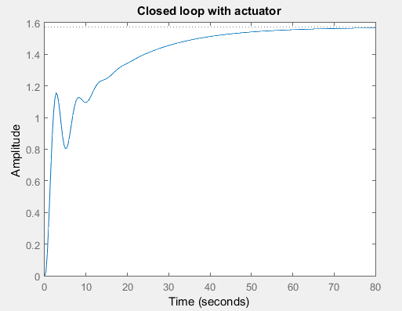

Poles at : -10.0746 + 0.0000j

-0.2981 + 1.2208j

-0.2981 - 1.2208j

-0.0682 + 0.0000j DOMINANT

Zero at : -0.1508

We see I have a steady state error of 57%

A 2% settling time of 49 seconds.

A DC gain of $\frac{0.17041}{1.57}=1.0854$

No overshoot.

What’s more if we look at our root locus we see that part of it lies within the right hand plane and it currently tends towards infinity.

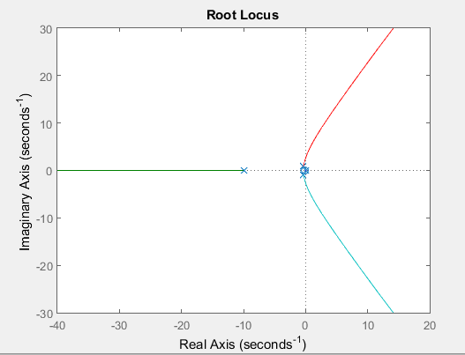

I then ran a check with an ideal PI controller and attempted to yield a satisfactory response however this proved impossible and so it was validated that a PID controller was used. 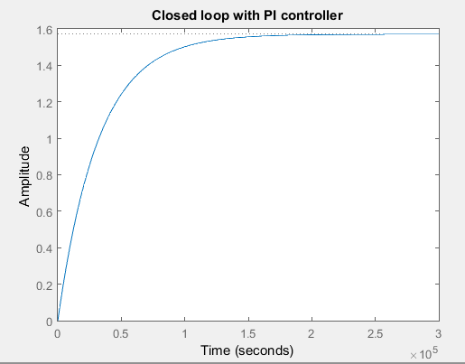

We do note however that a PI controller does improve our root locus very slightly. But still nowhere near the extent wher it is in anyway useful to us.

The above PI controller had the following constants, however any constants I tried gave a similar response.

k = .1;

z = 0.04;

p = 15;

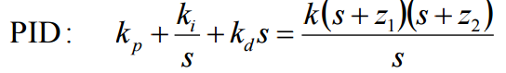

Now I designed my PID. I knew that I wanted my dominant pole to lie somewhere around the -0.8 region.

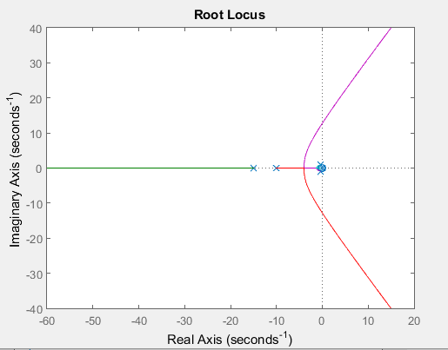

We know that we want our dominant pole to lie somewhere around the -0.8 mark.

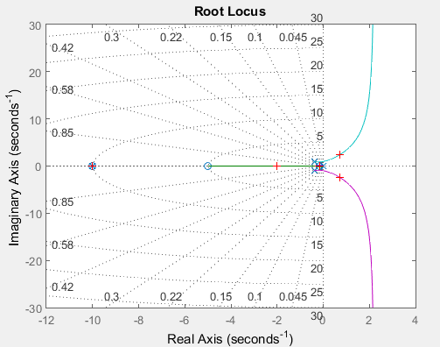

I tested with zeroes at -5 and -8 for my controller, as I wanted to use the rule of thumb that states that introducing zeroes deep into the left half plane will improve the speed of response, and a gain of 0.3535 which I found using rlocfind and clicking for a pole around -2 (it was actually 2.0136 + 0.0000i). I just used arbritrary values to observe how this affected my controller. We see that we have poles lying in the right hand plane so this controller is useless to us. It infact returned the following poles.

POLES: -10.0000 + 0.0000j

0.7135 + 2.3961j

0.7135 - 2.3961j

-2.0136 + 0.0000j

-0.1524 + 0.0000j

I tried reducing my zeroes to see the affect this had on the system. I tried a controller with zeroes at -5 and -2 and a gain of 0.2043 by using rlocfind and clicking a pole at -0.7370 +

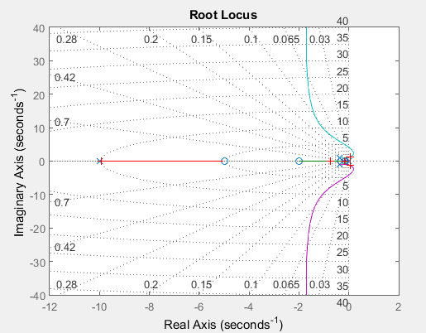

It is clear that this drastically improves my root locus. I still have poles in the right hand plane however the majority of my rootlocus now lies in the left hand plane. Using this knowledge I decided to pick zeroes very close to my imaginary axis. I chose the values -0.5 and -0.8 with a gain of 1.225e03 by again using rlocfind and entering a pole at -0.8.

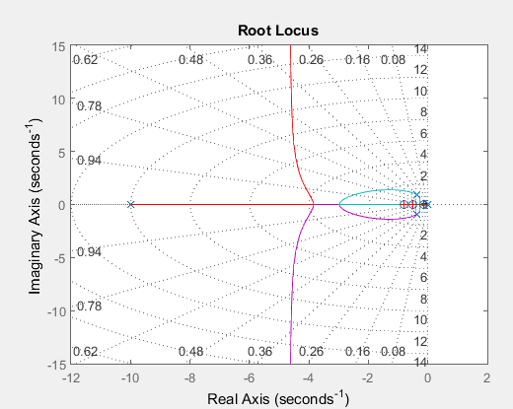

POLES: -4.6434 +93.7301j

-4.6434 -93.7301j

-0.8033 + 0.0000j

-0.4980 + 0.0000j

-0.1509 + 0.0000j

It is very clear we have a dominant pole at -0.1509 and we have a secondary group of poles close to the asymptotes of our root locus which is desirable, however using rlocfind has given us a gigantic gain which is causing rnging in our step response.

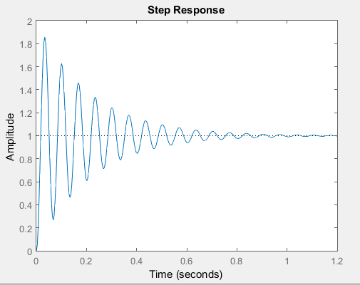

We note that our rise time is frighteningly quick and that there is significant ringing, however our system does have a steady state value of 1 which is desirable.

I then ran the same controller above with a new gain of 10.

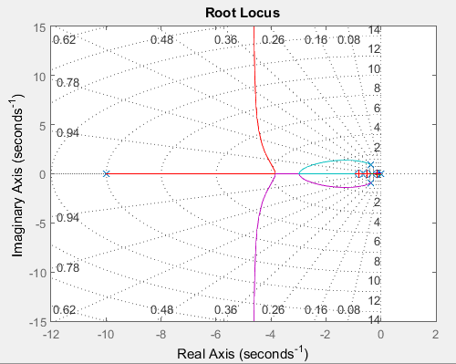

We note how k does not change the shape of our root locus however there is a drastic change in our step response.

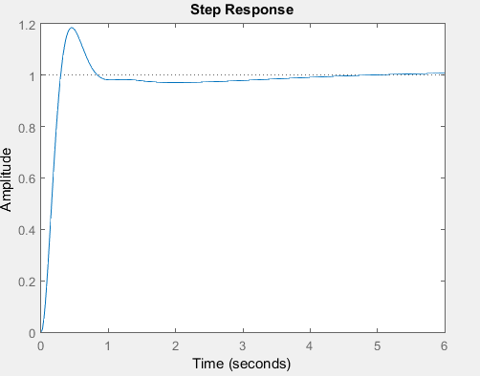

This is much more like the response we wish to achieve. We note that our rise time is still extremely fast at 0.198 seconds, but our steady state settling time is 3 seconds, and our overshoot fits the specifications too at 18.5%. This is very close to our max over shoot so I reduced my gain factor k to 7.

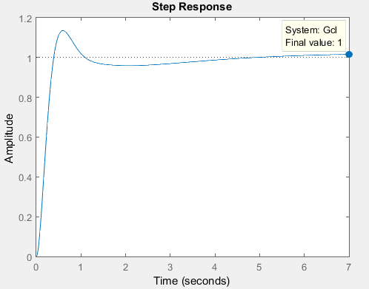

By doing this I have reduced my overshoot to 13.6% however I have had to make a trade-off with my settling time as it is now increased to 3.57 seconds. Despite what looks to be a discrepancy in the graph we also note that my steady state does return have zero steady state error, so I have met all the criteria for our PID controller. However, my rise time is 0.265 seconds which I feel is extremely quick, as a result I would state that my system is more an academic solution than a realistic one, as I do not expect the system to respond that quickly.

# Question 8

To test to see if my system was failsafe I investigated what happened when my gain my $k_{p}, k_{i} or k_{d}$ gains (which above I equated and used the one gain k) tended to infinity causing k to tend to infinity. So I swapped the current gain of my filter for 100billion. Again we know that the gain won’t affect our root locus, however our step response is wildly different.

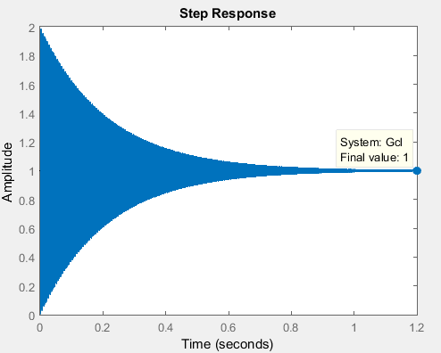

We see that an incredible amount of ringing occurs however our steady state value still has zero error. There’s no point in even mentioning the rise time it is that quick (to the order of 10E-5 seconds) and our settling time has reduced to 0.842 seconds. My percentage overshoot is now at 98.7% so we note that this does break our conditions, even though the setline time is quite fast and may well be a farcical value also. So if my gain tends to infinity this definitely breaks my system and shows it is not failsafe.

On the other end of the scale I then set my gain to 10E-9. Again we get a massive amount of ringing. Our steady state value still returns to 1 and our overshoot is 99.8%, quite similar to the previous value however our rise time and settling time have changed drastically. Our rise time is now in the order of 10E4 seconds with our settling time 1.85E9 seconds. This is obviously a stupid amount of time to wait for a system to settle so once again we’ve proven that the system is not failsafe if one of my gains tends to zero or infinity.

